**Project Automation (Dhara Barot – N01559954)**

1. **terraform init**

1. **terraform validate**

1. **terraform plan**

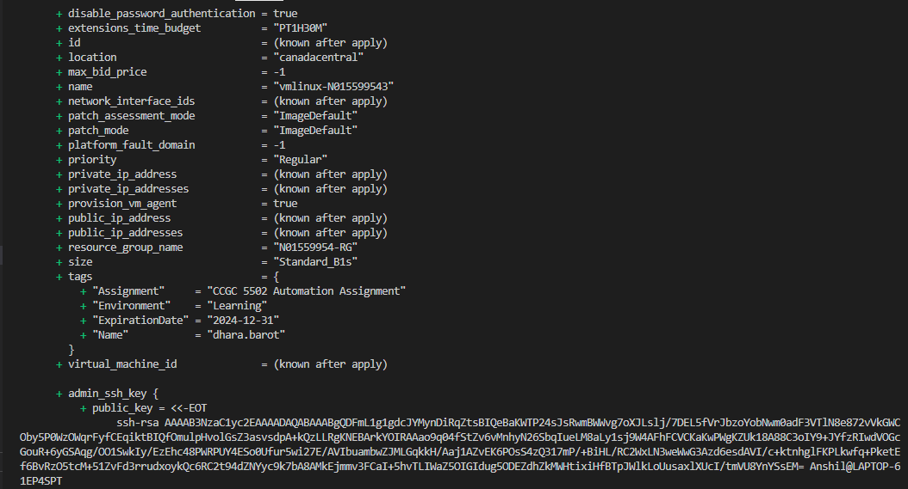

1. terraform state list | nl

1. **terraform output**

